**EXPERIMENT – 4**

**EXP NO 3: CREATE A SIMPLE CLOUD SOFTWARE APPLICATION FOR SMART CAR BOOKING USING ANY CLOUD SERVICE PROVIDER TO DEMONSTRATE SAAS.**

**DATE:**26/09/25

**AIM:**

To Create a simple cloud software application for Smart Car Booking

using any Cloud Service Provider to demonstrate SaaS.

**PROCEDURE:**

**step1:** Go to zoho.com.

**step 2:** Log into the zoho.com.

**step 3:** Select one application step.

**step4:** Enter application name as Smart Car Booking.

**step 5:** Created new application Smart Car Booking.

**step 6:** Select one form

**step 7:** The software has been created.

**OUTPUT:**

**FORM 1 –Car Details Form**

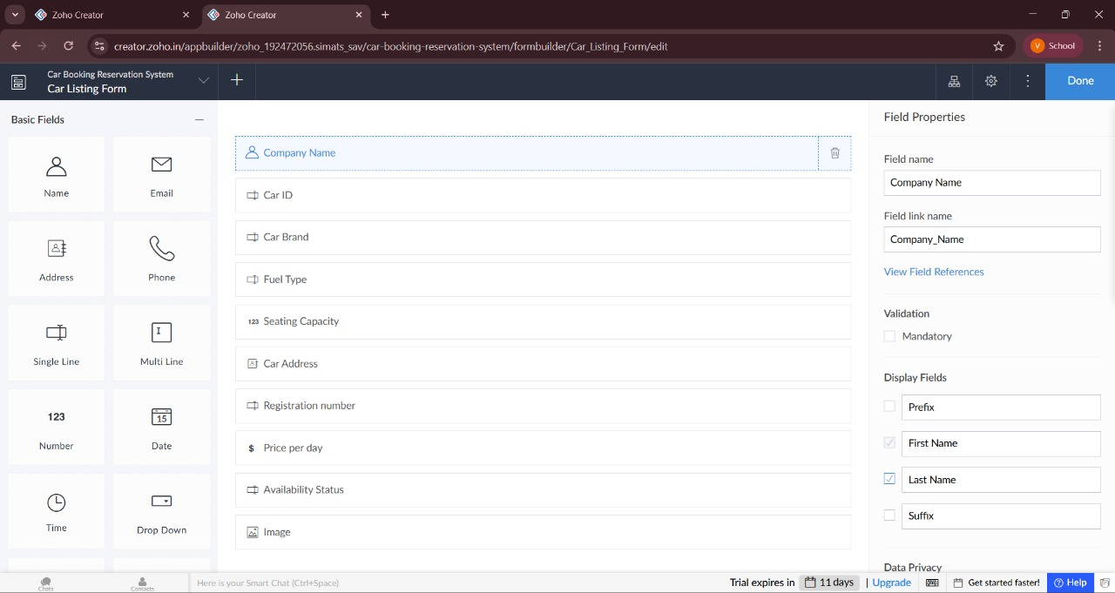

**FORM 2 –Customer Booking Form**

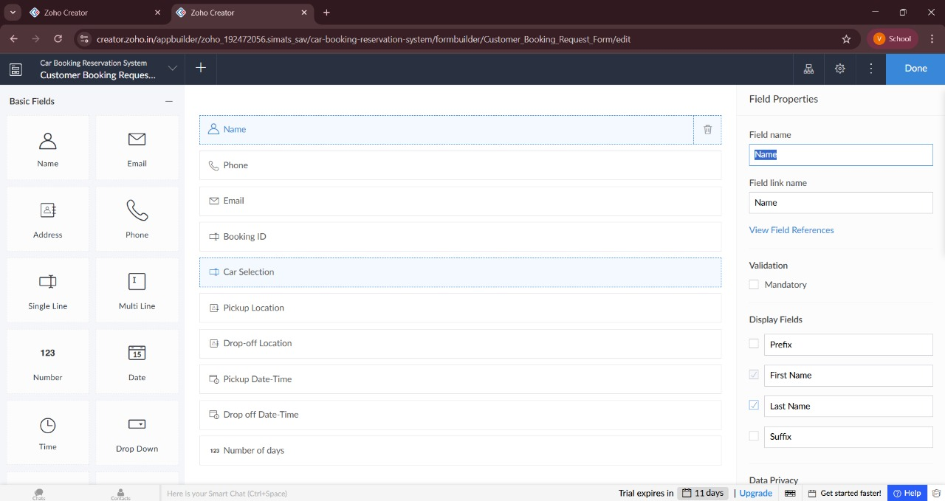

**FORM 3 –Booking Form**

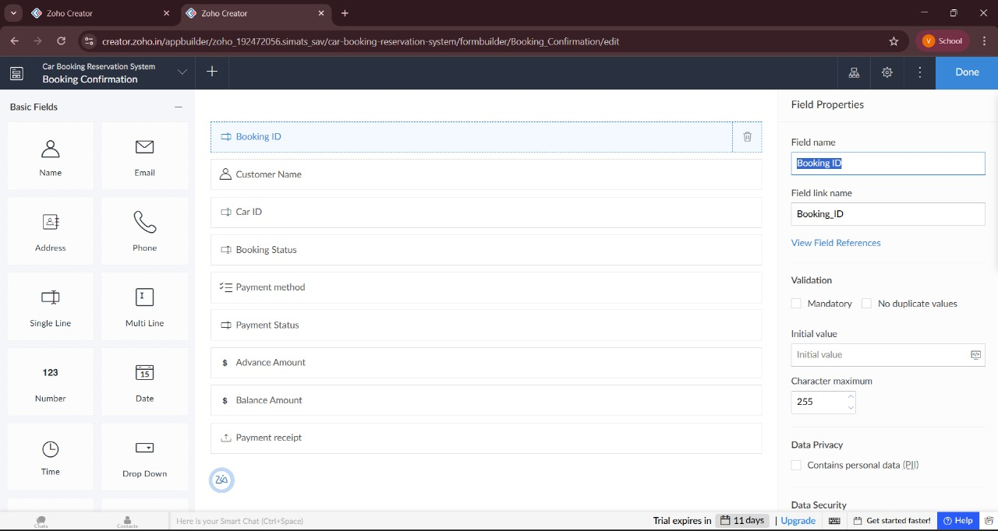

**FORM 1 – Car Details Form**

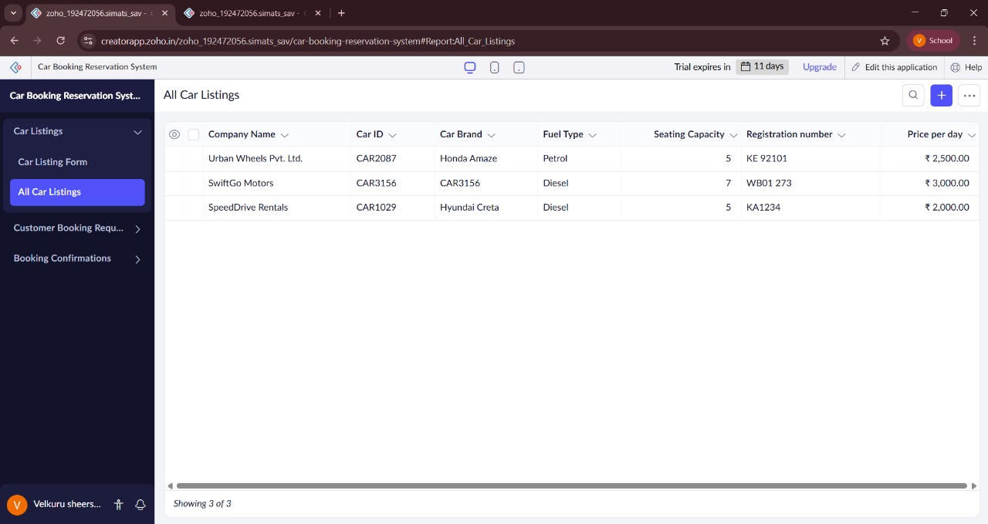

**FORM 2 – Customer Booking Form**

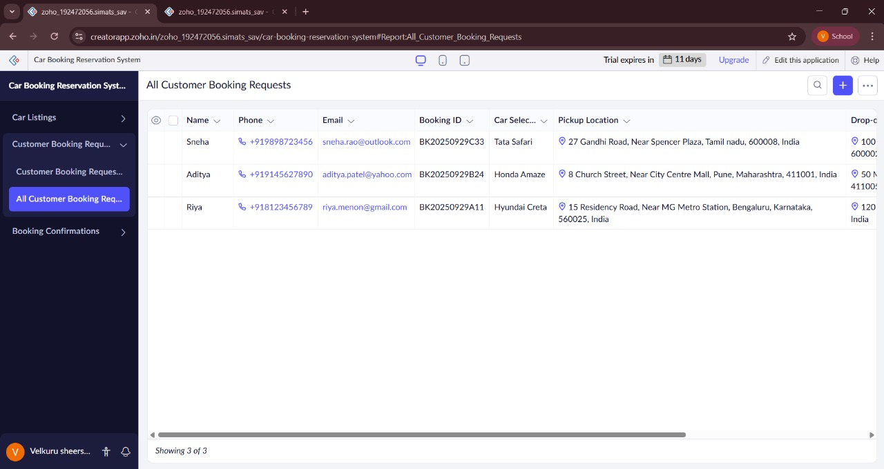

**FORM 3 – Booking Form**

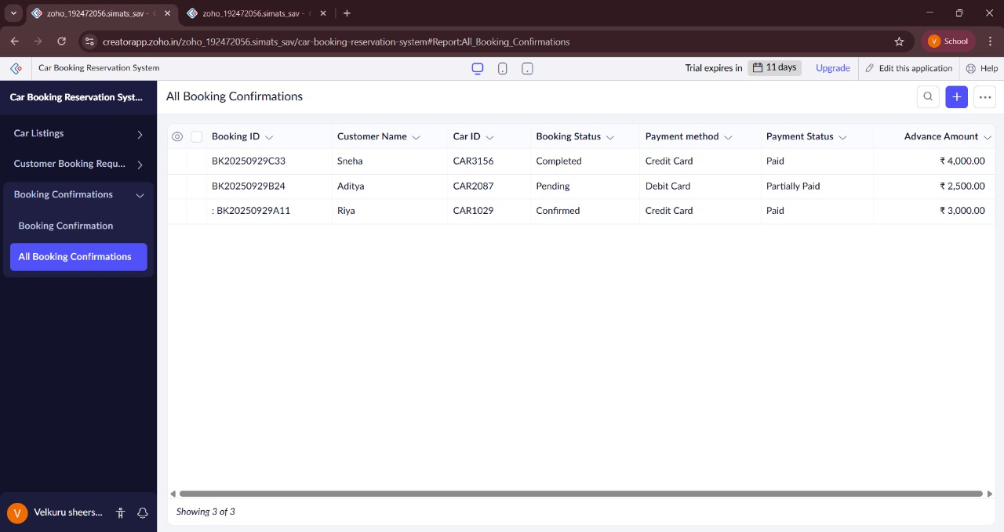

**RESULT:**

The **Smart Car Booking** application was successfully created using **Zoho Creator (Cloud SaaS platform)** with the following forms:

* **Car Details Form**
* **Customer Booking Form**
* **Booking Form**

This demonstrates **SaaS**, as customers can register, view available cars, make bookings, and check their booking status entirely online without installing any software.